
The Belton Beacon

April 2025

Lines Written in Early Spring
By William Wordsworth (1798)

I heard a thousand blended notes,
While in a grove I sate reclined,
In that sweet mood when pleasant thoughts
Bring sad thoughts to the mind.

To her fair works did Nature link
The human soul that through me ran;
And much it grieved my heart to think
What man has made of man.

Through primrose tufts, in that green bower,
The periwinkle trailed its wreaths;
And ’tis my faith that every flower
Enjoys the air it breathes.

The birds around me hopped and played,
Their thoughts I cannot measure: —
But the least motion which they made
It seemed a thrill of pleasure.

The budding twigs spread out their fan,
To catch the breezy air;
And I must think, do all I can,
That there was pleasure there.

If this belief from heaven be sent,
If such be Nature’s holy plan,
Have I not reason to lament
What man has made of man?

The other day, I watched The Avengers: End Game. Captain America noted with surprise that when the world’s population was cut in half due to a nefarious villain, it had unexpected consequences, such as pods of humpback whales beginning to live in the Hudson River again. It reminded me of COVID when reports of wildlife began strolling throughout Main Streets from LA to Greenville for the first time in decades. Like Wordsworth’s poem, these scenes confront us with the question of how our actions affect creation. Creation blossoms by itself. Are we helping creation flourish, or do we stifle creation’s beauty by what we do and what we don’t do?

Each Spring, we see creation awaken from its winter slumber. The melody of birds fills the air, the budding flowers dot our landscape, and as Wordsworth notes, creation begins to be filled with the thrill of pleasure. Each Spring thus gives us the opportunity to reflect upon our calling as stewards of creation. When God created humanity in the Garden of Eden, God gave them the task of working and keeping the Garden (Genesis 2:15). What a beautiful charge to work in God’s very creation and to keep, maintain, and safeguard its beauty, not to rule as kings and queens. There is one King of Creation; we have been lovingly created by this King, just as the robins, soil, dandelions, deer, and lilies. This King looks at us and invites us to work and keep God’s very creation.

This Spring, as you plant flowers, cut grass, walk the Bubblegum Rail Trail, go hiking, or sit on your back porch, I invite you to reflect upon Wordsworth’s poem and God’s invitation to work and keep creation. How can we better live into this holy calling in 2025 in our personal lives, as a community, a nation, and a world?

Facebook
Are you following us on Facebook?? If not, you’re missing out! We accept all friend requests and you’ll find all sorts of interesting updates posted.

Happy Birthday from your
church family!
April 3rd Annie Maynard
April 4th Angela Foster
April 6th Willie Mae Lee
April 15th Louise Blake
April 27th Cecil Perry

Calendar of Upcoming Events

Thursday, April 3 Lenten Service 11:00am
Monday, April 7 Lenten Study 6:30pm
Wednesday, April 9 Youth Group 5:30pm
Saturday, April 12 SC Chili Cookoff
Sunday, April 13 Palm Sunday
Thursday, April 17 Maundy Thursday 6:00pm
Saturday, April 19 Easter Brunch 11:00am
Sunday, April 20 Easter Sunday

Huggers Circle
Huggers Circle will meet on Wednesday, April 2nd at 10:00 in the Fellowship Hall. Hostess will be Pam Darby and she will be leading the lesson from It’s Okay Not to Be Okay: Moving Forward One Day at a Time.
The mission outreach for April is a
donation to Walk With the Docs.

Community Lenten Service
We are invited to join Lickville Presbyterian Church for this service on Thursday, April 3rd at 11:00am. There will be a light lunch to follow.

Lenten Study

What happened during Holy Week? Pastor Will is completing the series Lenten Study 6:30-7:30pm on Monday, April 7th.
We have been following Christ in his
last week on earth.

Soul Searchers

Meetings this month are Wednesday mornings at 10am – April 16th & April 30th.

Parish Care Team
Parish Team will meet Monday, April 14th at 10:00am to visit shut-ins. We’re looking for volunteers to make casseroles or goodies for us to deliver. There is a sign-up sheet in the Narthex. Please have these items in the refrigerator or freezer by the date stated. We send cards and deliver meals and flowers to those in our congregation and on our prayer list. We would love to have anyone join us in this ministry.

Maundy Thursday Service
Please plan to join us for this special worship service at 6:00pm on April 17th as we remember the Last Supper our Lord shared with his closest disciples. We will receive communion by Intinction.

The South Carolina Chili Cookoff

The Cookoff is on Saturday April 12th and we will have a table this year. Stephen & Cheryl Wellman will be preparing the chili. There is a signup sheet if you would be interested in volunteering to work at our table on that date. This is a great opportunity for us to connect with our community and to share about our church. We need folks to show up and show
out as this is one of our big mission projects
of the spring
Christian Education Committee
Please mark your calendars for our 2025 Easter Brunch Extravaganza! It will be a potluck event at the manse on Saturday, April 19th at 11:00 and ALL are welcome. There is a signup sheet in the Narthex. Christian Ed will provide the drinks. Tables will be delivered but this is a BYOC (Bring Your Own Chair) event. We will eat first, then hunt & play games. Please bring your own basket. We will have 3 egg hunts: 1 for the littles, 1 for the youth and 1 for the ADULTS!!!!! This year the games include the Jello Egg Toss, Carrot Toss and the Jelly Bean Push. If these sound interesting or you wonder “what is that?”, make sure to put the date on your calendar for the “can’t miss” event of the year!
Christian Ed Committee is asking for donations of candy for the Extravaganza egg hunt by April 16th – no chocolate please.
Please remember that May 4th is Graduate Sunday. We have two graduates. Please plan to join us in congratulating and honoring these hardworking individuals. Boyd Maynard is graduating from Belton Honea Path High School. Gus Blake is graduating from Wofford College. We will have lunch after the service. Please check the bulletin & newsletter for other upcoming events.

We are very excited about our Vacation Bible School this year on August 2nd. We will have programs for children, youth, women, and men this year. We would love for you to participate or help us put on the best VBS Belton Presbyterian has ever had!

Worship Committee

“Hosanna in the highest”
We are in the middle of Lenten Season, a glorious time in the life of our church.
I’m sure you have noticed our sweet acolytes extinguishing a candle each Sunday until the Christ Candle is extinguished during our Maundy Thursday service not Easter...
on Easter he lives!!!

Palm Sunday is April 13th. We plan on everyone who wants to process, to follow in behind the choir waving our palm branches.

“He is Risen”
Easter Sunday is April 20th.
This year we are doing something new! We will have a wire covered wooden cross set up in front of our church facing Main Street. Be thinking of flowers you can bring from home
to help decorate for a beautiful display on the cross. A big thank you goes out to Jay Blake
for making the cross for us. Worship Committee hopes to see everyone here to renew your faith or just rest in the beauty of the season.

Lunch Bunch
Please plan to join us! Our next outing to Grits & Groceries will be Thursday, April 24th. Watch for details in the bulletin.

Pianist Search Task Force
Our group is dreaming big as we begin searching for a pianist this month. Committee members are Vickie LeHeup, Andrea Burriss, Jeanne Henderson, Frances Russell, Tanner White, Rowe Henderson (chair) and Will DeLaney. If you have any comments, suggestions, or name
of a candidate to be considered, please direct
them to a committee member.

News from the Session

Each committee was tasked with discerning one goal for the life of our congregation between now and summer. These goals resemble the priorities of church leadership for
the Spring of 2025.

Worship: Delegate worship activities to more in the church. (Communion set up, greeters, ushers, parament changes)
Mission: Have Shalom House come and share information with our congregation and further solidify our relationship with them.
Membership: Have one large church fellowship event each quarter.
Pastor Will: To volunteer at BIMA 1 or 2 times each month.
Building and Grounds: Completing outstanding electrical projects around church, including Fire Marshall items.
Administration and Finance: Discerning how the manse property can help us financially flourish for years to come.
Christian Education: Focus on having a memorable and fun Easter Brunch and Eggstravaganza for all ages.

Mission Committee
On Palm Sunday we will be receiving our special offering for One Great Hour of Sharing. Join with Presbyterians worldwide in sharing God’s love with our neighbors in need around the world by providing relief from natural disasters, food for the hungry, and support for the poor and oppressed.

Venmo account for Giving and Tithing

We now have a Venmo account in order for you to easily give your tithes and offerings.
@Belton-Presbyterian Code - 0471
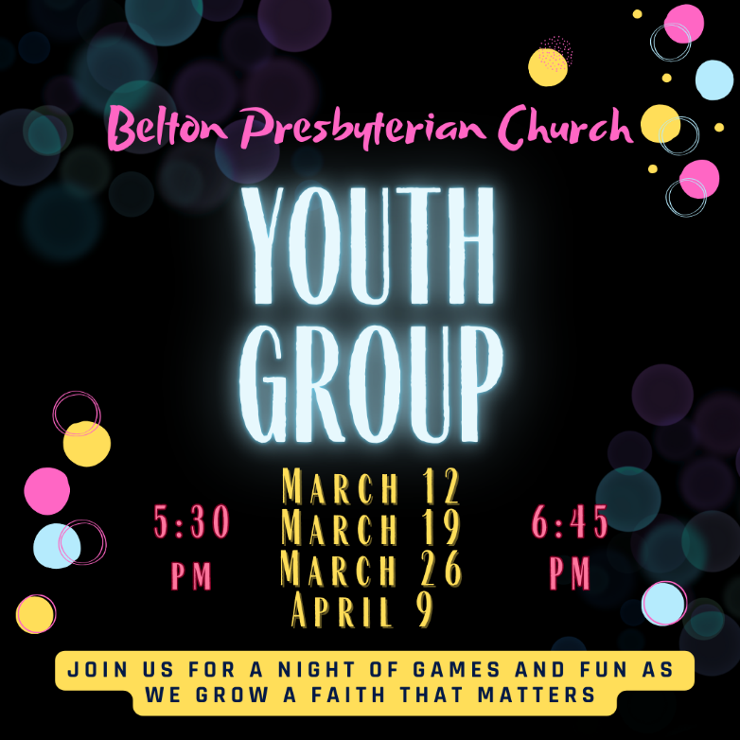

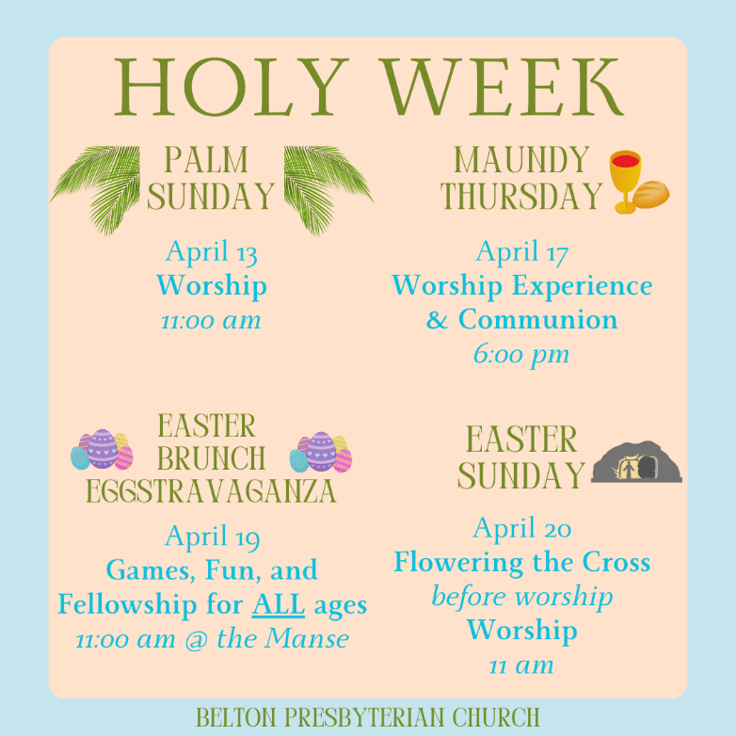

ADMINISTRATIVE / FINANCE COMMITTEE

Financial Results thru March 2025
ACTUAL BUDGET

Monthly Giving / Contributions – Non-Designated $ 39494 $ 45459

Other Designated Contributions
Building Fund $ 175
Memorial Fund $5225
Mission Fund $ 700
Parish Care Fund
Soup Sunday
Beautification Fund
Hurricane Helene Relief
Women’s Retreat Contribution
Emergency Relief Escrow
----------
Total (Designated) = $ 6100

Expenses

Admin Expenses $ 22784 $23902
Facilities Expenses $ 11448 $ 9575
Worship Expenses $ 5737 $ 7426
Christian Education Expenses $ 353 $ 626
Fellowship Expenses $ 10 $ 432
Mission Expenses $ 0 $ 3495

Total Expenses = $ 40332 $45456

Surplus or <Deficit> <$838>

GENERAL COMMENTS

March Contributions to the General Fund were $16582 with YTD Actual Contributions of $39494. This results in a <$838> DEFICIT compared to YTD Actual Expenses of $40332.

Manse Status…..

Session approved a recommendation from the Administrative Committee to evaluate the possibility of renting or selling the Manse at market value. Currently working with the Foothills Presbytery on this overall analysis. More information will be forthcoming in the next few months.

