
The Belton Beacon

February 2025

February is often called the month of love. Some plan extravagant trips, while others try to block out the heart-shaped decorations and lovey-dovey posts on social media. For some, this month overflows with joy; for others, it reminds you of your scars and wounds.
And yet, while the church does not follow the secular calendar (there is good reason for this), February does invite us to pause and reflect upon God’s love. Presbyterians spend A LOT of time talking about God’s love, and there is good reason for that. Yes, we will each stand in front of the judgment throne of God one day. Yes, God expresses his wrath against our individual and systemic sins. And yet, in the same breath, we affirm that God is primarily a God of love. When Jesus, the “image of the invisible God” (Colossians 1:15), came to earth, he came not as an executioner but a humble servant.
We repeat John 3:16-17 so often because it captures God’s love: “For God so loved the world that he gave his only Son, that whoever believes in him should not perish but have eternal life. For God sent the Son into the world, not to condemn the world, but that the world might be saved through him.” John captures these famous verses in 1 John 4:8-10 in this way, “God is love. This is how the love of God is revealed to us: God has sent his only Son into the world so that we can live through him. This is love: it is not that we loved God but that he loved us and sent his Son as the sacrifice that deals with our sins.”
Do you see why we focus on God’s love so much as Presbyterians? When we take the Scriptures seriously, we are confronted not with a bloodthirsty judge but a loving parent who runs to meet the prodigal.
Maybe, just maybe, in our world of heightened division, injustice, and violence, maybe, just maybe, our greatest gift to the world is the raw and authentic love of God. Maybe, just maybe, our greatest evangelism tool is not scaring people but inviting them to experience God’s raw and authentic love. If we want our brothers and sisters in our community and across our world to repent and come to Christ, maybe, just maybe, it begins with them coming face-to-face with the one whose love is not for the perfect but for the sinner, just like you and me.
This month, I invite you to reflect upon these questions… feel free to share your revelations with me!
How have you experienced God’s love in your life?
What are three ways we, as a church, can be a beacon for God’s love in our community?
How can you intentionally share God’s love in your personal life?


February 8 – Eugene Dickert
February 12 – Alexander Jones
February 12 – Theresa Shirley
February 13 – Bethany Wiley
February 21 – Juanita Hembree
February 24 – Richard Dorn
Happy Birthday from your church family!
Soup to Go Sunday
The Huggers Circle will be preparing vegetable beef soup for take-out on Sunday, February 23rd. Let us do your lunch that Sunday! There is a signup sheet in the Narthex to pre-order. Quarts will be $9.00.
Lunch Bunch
We will be going out for lunch at 11:15 on Tuesday, February 25th. Our destination is The Village Bakery & Café in Pendleton. There will be a signup sheet in the Narthex.
Please plan to join us!

Soul Searchers
This Presbyterian Women’s circle group
is open to all women (so invite your friends)! Soul Searchers began meeting on Wednesday, January 29nd at 10:00am. The dates for February are 2/12 and 2/26. Will DeLaney is leading us in studying Carol Wehrheim’s book Getting It Together: Spiritual Practices for Faith, Family, and Work. If you would like to order a book from Amazon, it is $16, but it is not mandatory to have a book.

Youth and Children News
We will be going to Winter Jam at The Well in Greenville on Friday, February 21st. This is our first partnership with Honea Path Presbyterian Church for children/youth ministry. We will be doing more events with Honea Path Presbyterian Church in the future, so stay tuned for exciting things coming up.

Huggers Circle
Huggers Circle meets on Wednesday, February 5th at10am. Hostess this month will be Frances Saville. The lesson will be taught by Pam Darby from the book
It’s Okay Not to Be Okay:
Moving Forward One Day at a Time.

Updating Church Safety

We have new fire extinguishers on both ends of the hallway, in the kitchen, in the “flower room” next to the organ, and under the AED kit. Please familiarize yourself with their locations as well as the location of the Exit signs. Thank you to the Building &
Grounds Committee for their hard work. They are continuing to update the
emergency lights in the building.

Parish Care Team
We will be meeting in the Fellowship Hall on Monday, February 10th at 10:00am. If you are able to make a meal, dessert, or buy fresh produce or goodies for the Parish Care Team to deliver, please have these items in the refrigerator or freezer by the date of the meeting.

Venmo account for Giving and Tithing

@Belton-Presbyterian Code - 0471

Administrative / Finance Committee
Financial Results thru January 2025
ACTUAL BUDGET
Monthly Giving / Contributions – Non Designated $ 9456 $ 15153
Other Designated Contributions
Building Fund $ 70
Memorial Fund
Mission Fund $ 100
Parish Care Fund
Children/Youth
Beautification Fund
Hurricane Helene Relief
Women’s Retreat Contribution
Emergency Relief Escrow
----------
Total (Designated) = $ 170

Expenses
Admin Expenses $ 9625 $ 7968
Facilities Expenses $ 4457 $ 3192
Worship Expenses $ 1750 $ 2475
Christian Education Expenses $ 0 $ 209
Fellowship Expenses $ 0 $ 144
Mission Expenses $ 0 $ 1165

Total Expenses = $15832 $15153

Surplus or <Deficit> <$6376>

GENERAL COMMENTS
2025 Budget - The new budget was approved by Session in December and distributed to congregation
last week.
2024 Budget - $161791
2025 Budget - $181836 – Increase of $20045 (+12%)
The new budget will be challenging with increases mainly in Administration and Insurance, and our continued
regular giving and support will be extremely important.
Manse Status…..
Session approved a recommendation from the Administrative Committee to evaluate the possibility of renting
or selling the Manse at market value. Currently working with the Foothills Presbytery on this overall analysis.
More information will be forthcoming in the next few months.

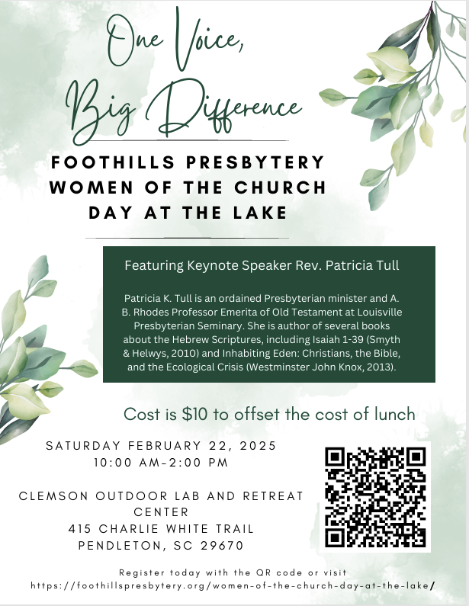

Please sign up on the sheet in the Narthex. You will also need to register by scanning the QR code
or contacting the office to complete your registration.
If you need help covering the cost for the event, please let the office know.

