
The Belton Beacon

January 2025

Every Saturday, when I wind our old Seth Thomas mantel clock, I feel that passage of time, O God.
Perhaps it is good that the clock keeps ticking though – to remind us that we haven’t got forever.
Help us turn our time to good account in acts of loving-kindness, in caring for others, and in praising
you for the many blessings of life – even the humble, humdrum ones.
So may we glorify you every waking hour, seven days a week – whether the time be Standard or Daylight, Eastern or Central, or Greenwich Mean! AMEN.

From “Prayers that Sing & Stir the Heart” by Dr. Wayne Sibley Towner (Presbyterian minister and professor at Princeton, Yale, University of Dubuque, and Union Presbyterian Seminary)

On New Year’s Day, we eagerly peer out from the humdrum of life to see all the possibilities that may come our way this year. Maybe I will get a promotion, finally buy that car, or go on that trip I have dreamed about for years. Perhaps I will retire (or unretire). The newness of the year is thrilling. Whatever held us back or went wrong in 2024 seems to wither away, and all our dreams and desires lay right in front of us, ready to be seized. It is like turning a page—or better yet—the beginning of a new chapter in your life story.

And yet, while we are focused on the new, new, new, Scripture reminds us that God remains the same. God’s character, promises, and plans are the same yesterday, today, and tomorrow. The God who was with you last year is with you this year. The God who comforted you during that time of illness or loss still comforts you. The God who spurred, convicted, and challenged you is still nudging you today. The one who created you and died for you still loves you today.

There is great comfort in knowing that as the psalmist says “Your Word, O Lord, stands firm in heaven forever! Your faithfulness extends from one generation to the next! You set the earth firmly in place, and it is still there. Your rules endure to this day because everything serves you… I’ve seen that everything no matter how perfect, has a limit, but your commandment is boundless” (Psalm 119:89-91, 96).

While the seasons change, the year changes, and life changes, we have one and only one constant: God. As God says, “I am the Alpha and the Omega, the one who is and who was and who is to come, the Almighty” (Revelations 1:8).

I invite you to pause at the start of this year and to reflect upon these questions:
Why is this Good News for you… for your loved ones… for the world?
How can this Good News strengthen your faith throughout the year—on the joyful days, the challenging days, and the ordinary days?

Happy Birthday from your church family!
January 1 Betsy Chapman
January 5 Dion Jones
January 5 Stephen Wellman
January 12 Brice Maynard
January 14 Sammy Chapman
January 16 Rowe Henderson
January 16 Margaret King
January 17 Lettie Porter
January 18 Joe Sherard
January 23 Kathi Christopher
January 25 Bill Shirley
January 27 Rosemary Kiser
January 29 Cyndy Epting
January 31 Noel Foster

News from the Session
The Elder Class of 2027 are Jim Bright, Frances Russell, Tanner White and Al Young will be ordained and installed.

Thanks to Scott Bullions, Richard Dorn, Vickie LeHeup and Pam Wright for serving faithfully these past few years.

The Session has called a Congregational Meeting on Sunday, January 26th. This meeting will serve as our annual Congregational Meeting. We will approve the Terms of Call for Reverend Will DeLaney. The congregation will also receive the 2025 budget. Copies will be available to be picked up in the Narthex on January 19th.

Celebration for Ann Berry

On Sunday, January 19th, we will be having a celebration and joyful sendoff to retirement for Ann Berry.

Venmo account for Giving and Tithing

We now have a Venmo account in order for you to easily give your tithes and offerings.
@Belton-Presbyterian Code - 0471

Lunch Bunch
We will be going out for lunch at 11:30 on Monday, January 20th. If you have a recommendation for a restaurant that is open on Mondays, please let the office know. There will be a signup sheet in the Narthex.
Please plan to join us!

Mission Committee
Pam Darby, Caroline Jones & Kim Harper presented a Christmas craft event at the Shalom House Ministries in December for the residents. Each participant completed a handcrafted item for their personal use.

The final year-end Mission Contributions from BPC to various charitable agencies were distributed during the fourth quarter. Those receiving the gifts included:
Foothills Presbytery $4,175.00
Shalom House Ministries $1,600.00
Meals on Wheels $800.00
BIMA $1,000.00
Thornwell Children's Home $1,700.00
Christmas Joy Offering $200.00

The members of the Mission Committee would like to thank all who supported its mission centered activities during 2024. Much was accomplished but, as always, much remains to be done. We hope all will have a Blessed and Happy New Year!

Love Offerings

We were so blessed in November to have two choral groups to join us in leading worship. Through your generous offerings, we were
able to send $1367.00 to BHP Choral Department and $1239.00 to
Erskine College Choral Department.

In addition to these love offerings, we received scholarship donations of $1475.00 to add to an individual BHP student’s account in order for him to have the funds needed to travel with
his group to Los Angeles.

Soul Searchers
This Presbyterian Women’s circle group
is open to all women (so invite your friends)! Soul Searchers will begin meeting on Wednesday, January 22nd at 10:00am. Will DeLaney will be leading us in studying Carol Wehrheim’s book Getting It Together: Spiritual Practices for Faith, Family, and Work. If you would like to order a book from Amazon, it is $16, but it is not mandatory to have a book.

Youth and Children News
You will be going to Big Air in Anderson
on Sunday, January 19th. Stay tuned for
exciting upcoming events.

Huggers Circle
Huggers Circle meets on the first Wednesday of each month at10am. The lesson will be taught by Pam Darby from the book It’s Okay Not to Be Okay: Moving Forward
One Day at a Time.

Contact Information
If you would like to update your contact information, please let the office know by January 20th. We will be preparing a new index with information for your pictorial directory.
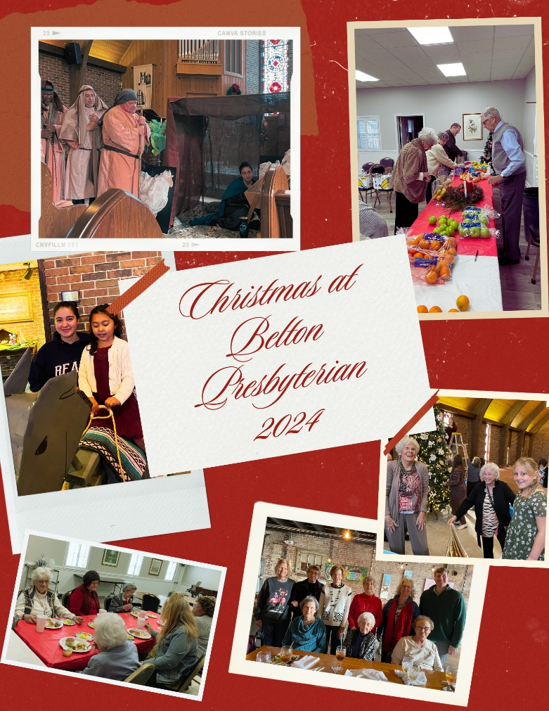

Parish Care Team
If you would like to join the Parish Care team, we will be meeting in the Fellowship Hall on Monday, January 13th at 10:00am. If you are able to make a meal, dessert, or buy fresh produce or goodies for the Parish Care Team to deliver, please have these items in the refrigerator or freezer by the date of the meeting. We send cards and deliver meals and flowers to those in our congregation and on our prayer list.

Congratulations

Will DeLaney has been elected by Foothills Presbytery to serve a three-year term on the Committee on Shared Ministry. He will serve on the mission sub-committee whose focus is planning and implementing shared mission projects throughout the upstate.

Administrative / Finance Committee
Financial Results thru December 2024
ACTUAL BUDGET
Monthly Giving / Contributions – Non Designated $171141 $161791
Other Designated Contributions
Building Fund $3040
Memorial Fund $ 350
Mission Fund $5001
Parish Care Fund $ 590
Children/Youth $ 114
Beautification Fund $7000
Hurricane Helene Relief $1631
Women’s Retreat Contribution $ 550
Emergency Relief Escrow $1000

Total (Designated) = $19276
Expenses
Admin Expenses $ 97154 $ 80341
Facilities Expenses $ 37516 $ 36930
Worship Expenses $ 29552 $ 29374
Christian Education Expenses $ 941 $ 700
Fellowship Expenses $ 880 $ 1730
Mission Expenses $ 12968 $ 12716

Total Expenses = $179012 $161791
Surplus or <Deficit> <$7871>
GENERAL COMMENTS
Overall Financial Results
Congratulations on December’s Contributions to the General Fund of $22493!! YTD Actual Contributions ($171141)
now show a <$7871>DEFICIT compared to YTD Actual Expenses ($179012). December’s contribution levels
improved our overall YTD DEFICIT by $1793 compared to last month’s YTD <$9654> DEFICIT results!!
2025 Budget - The new budget was approved by Session in December:
2024 Budget - $161791
2025 Budget - $181836 – Increase of $20045 (+12%)
The new budget will be challenging with increases mainly in Administration and Insurance, and your continued
regular giving and support will be extremely important.
Manse Status…..
Session approved a recommendation from the Administrative Committee to evaluate the possibility of renting
or selling the Manse at market value. Currently working with the Foothills Presbytery on this overall analysis.
More information will be forthcoming in the next few months.

