
The Belton Beacon

March 2025

Happy Anniversary, Church Family!!!
Can you believe that as of March 18th, we will be together for an entire year? What a year it has been. My heart overflows with joy as I remember this year like when we shared in a moving Christmas Eve service to our belly-filled laughter at Lunch Bunch to getting our hands dirty side-by-side in impactful mission work across our community. As the morning sun rises each day, so am I filled with delight as I think about walking alongside each of you in this life. Whether it is at the hospital bedside, a BHP ball game, the coffee shop, in the sanctuary, or over a meal, I treasure each holy moment we are sharing together. Thank you for making Madison and me a part of this family. I am humbled by the bonds we are quickly building, the trust that we are cultivating, and the love we share. I thank God for the opportunity to be a part of this family. I thank God for you. I thank God for our community.
My winter continuing education conference this year was called “The Power and Privilege of Preaching” led by some of the giants of our Reformed Tradition, Dr. Kevin DeYoung and Dr. John Piper. As John Piper articulated to the 500 pastors present, pastors are called to spend their days immersed in God’s Word and labor as the means (the agent) by which their flock cultivates a delight in God and a saving faith. As I sat in that room, I was overcome with immense joy, knowing that you have chosen me to spend my days in intentional prayer, reading Scripture, and proclaiming God’s goodness in our community and with you in my heart. Thank you for your trust. Thank you for this holy privilege.
I am excited to see where God takes us this year. Can you feel the Spirit moving in our midst? Do you perceive that God is doing something big? I am excited to see what adventure God has for us next.

Be sure to check out our website www.beltonpc.org
Our wifi name & password has changed
Username: BPC
Password: greenpanda492

Happy Birthday from your
church family!

March 8 Mary Anne Lake
March 11 Meghan Lollis
March 13 Charles LeCroy
March 21 Trisha Henderson
March 22 Madison DeLaney
March 25 Jean Anne Maynard
March 27 Caroline Jones
March 28 Chris Lollis
March 29 Margaret Dickert
March 30 Ian Wiley
Calendar of Upcoming Events
Wednesday, March 5 Ash Wednesday 6:00pm
Monday, March 10 Lenten Study 6:30pm
Wednesday, March 12 Youth Group 5:30pm
Sunday, March 16 Soup/Game Night 5:00pm
Monday, March 17 Lenten Study 6:30pm
Wednesday, March 19 Lunch Bunch 11:15am
Wednesday, March 19 Youth Group 5:30pm
Monday, March 24 Lenten Study 6:30pm
Wednesday, March 26 Youth Group 5:30pm
Monday, March 31 Lenten Study 6:30pm
Monday, April 7 Lenten Study 6:30pm
Wednesday, April 9 Youth Group 5:30pm
Saturday, April 12 SC Chili Cookoff
Sunday, April 13 Palm Sunday
Thursday, April 17 Maundy Thursday 6:00pm
Saturday, April 19 Easter Brunch 11:00am
Sunday, April 20 Easter Sunday

Facebook
Are you following us on Facebook?? If not, you’re missing out! We accept all friend requests and you’ll find all sorts of interesting updates posted.

Pianist Search Task Force
Our group is dreaming big as we begin searching for a pianist this month. Committee members are Vickie LeHeup, Andrea Burriss, Jeanne Henderson, Frances Russell, Tanner White, Rowe Henderson (chair) and Will DeLaney. If you have any comments, suggestions, or name
of a candidate to be considered, please direct
them to a committee member.

Venmo account for Giving and Tithing

We now have a Venmo account in order for you to easily give your tithes and offerings.
@Belton-Presbyterian Code - 0471
Huggers Circle
Huggers Circle will meet Wednesday, March 5th at 10:00 in the Fellowship Hall. Hostesses will be Judy Young & Rose Shirley. Pam Darby will be teaching the lesson from It’s Okay Not to Be Okay: Moving Forward One Day at a Time.
Parish Care Team
Parish Team will meet Monday,
March 10th at 10:00am to visit
shut-ins. We’re looking for volunteers
to make casseroles or goodies for us to deliver. There is a sign-up sheet in the Narthex. Please have these items in the refrigerator or freezer by the date stated.

Ash Wednesday Service

Our Ash Wednesday Service will be on March 5th at 6:00pm. For anyone who is unable to attend this service, you are invited to drop by the church at any point between 12:00-1:00pm for imposition of ashes by Pastor Will.
Lenten Study

What happened during Holy Week? Pastor Will is leading a Lenten Study for 5 consecutive Mondays 6:30-7:30pm, beginning on March 10th. We will be following Christ in his last week on earth. Hope you can come
15 minutes early for an informal time of fellowship at 6:15.

Soul Searchers
This Presbyterian Women’s circle group
is open to all women. Meetings this
month being led by Pastor Will are
on Wednesday mornings at 10am –
March 12th and March 26th.

Membership Committee

Mark your calendars for a fun night on Sunday, March 16th at 5:00! The committee is planning a soup/games night. There is a signup sheet in the Narthex. You can also mark if you will volunteer to bring soup, dessert or games.
Lunch Bunch
Please plan to join us! We will be heading to Clemson for our next culinary adventure on Wednesday, March 19th. A signup sheet is in the Narthex. We plan to leave the church at 11:15.
Ark Encounter & Ohio Amish Trip

Judy Young is a group leader and has provided information about this 4-day trip with
Christian Tours – May 21-24, 2025.
If you are interested in going, please pick
up a copy of the flyer in the Narthex and talk
to Judy for more information.

Grief Share Group

Honea Path Presbyterian Church is hosting a grief share group this Spring for those who
have lost a loved one. It meets at 2pm on Wednesdays at Honea Path Presbyterian
from March 5th to May 28th.

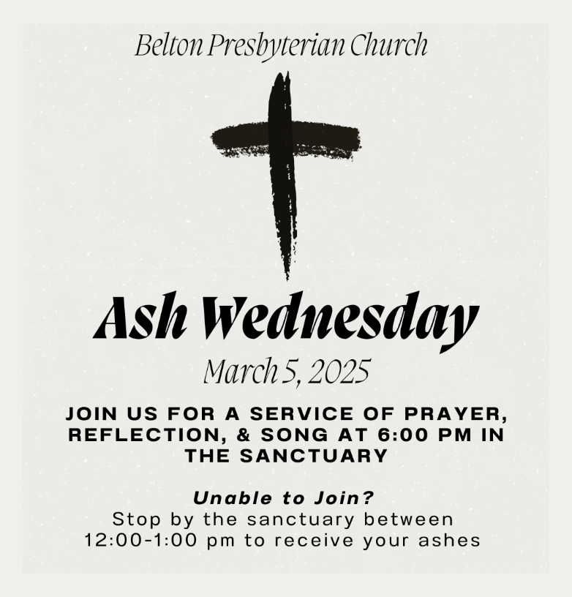

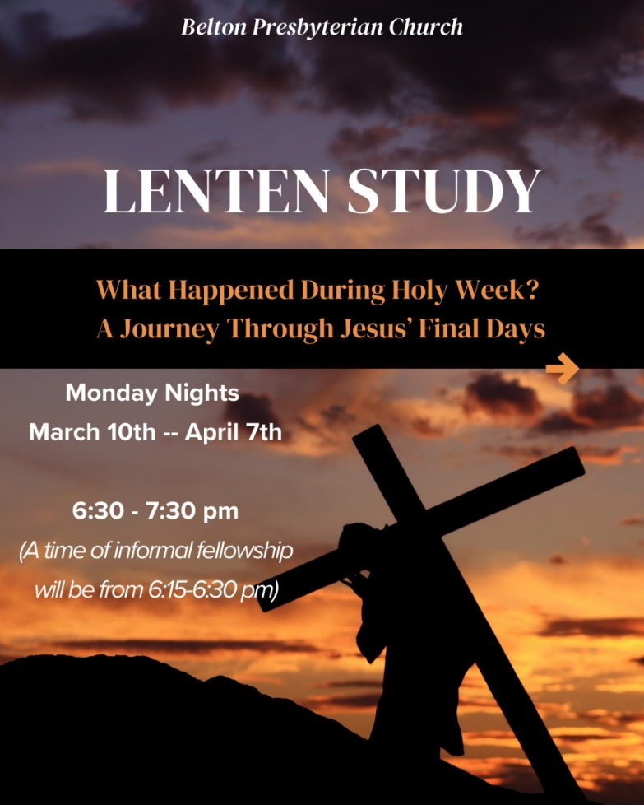

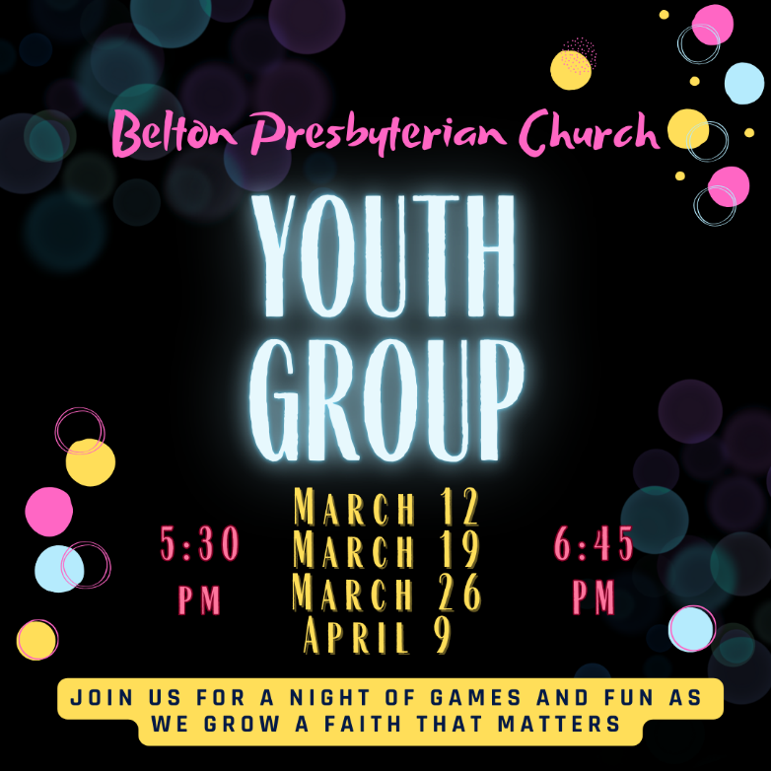

News from the Session

Starting in 2025 there will be a report of happenings from Session meetings in each Belton Beacon. Our goal is to increase transparency and make you aware of the actions and decisions of our governing board. If you have any questions, please reach out to Pastor Will or any member currently serving on Session.
January – Highlights
Scott Bullions (chair) and Dan Christopher will lead an initiative to compile a policy & procedure manual to bring us into compliance with the Presbytery.
Money from the Beautification Fund will be used to remove 3 trees and prune other trees.
Update – work is still in progress.

We are beginning a partnership with Honea Path Presbyterian Church to start a youth group for students across the Belton-Honea Path area.
Andrea Burriss will be joining our church via a transfer of letter.
Jay Blake and Gus Blake will be joining our church via letters of transfer. August Lyles Blake will be joining by Profession of Faith. We will be welcoming them in a service in March/April.
Mission Committee possible projects for 2025 include Chili Cookoff, bikes for BIMA, Blood Drive, Shalom House, yard sale, and mental health for our community.
A motion from Worship Committee to have communion on February 2 was approved.
February – Highlights
The following have agreed to serve as Clerks for 2025 during meetings: Judy Young, Lisa Jameson, and Pam Wright.
A motion was made & carried to accept Stephanie Hunter’s request to return as a member of the Belton Presbyterian Church. We will be welcoming her during a service in March.
Caroline Foster will be baptized on March 9th.
A motion was made & carried to begin replacing lighting in and around the church in the amount of $1,850.00.

